SCUOLA INTERNAZIONALE MUSHING – S.I.M. Fusine -Tarvisio
in collaboration with
FEDERAZIONE ITALIANA MUSHER SLEDDOG SPORT – F.I.M.S.S.

Invite you to the 3rd Edition of the

MEETING –TRADE FAIR of the MUSHER
SATURDAY the 22nd SEPT. 2007 at 10 a.m.

and the

10th TROPHY “TRIPLA CORONA“ Int’ l Dryland
DOG - TREKKING, BIKE – DOG, KART – DOG Race
“ CHALLENGE ITALIA CUP “- FIMSS / ESDRA CUP
PIANA DI FUSINE – TARVISIO ( UD )
Race Area Via Ponze, Bar - Lodge “KANTINA” at the Italy-Slovenia border

SUNDAY the 23rd SEPT.2007 at 10 a.m.

International Race for Adults ( Km. 4 ) and Juniors ( Km. 2 ) with all kind of Sled Dogs, pure Nordic breeds and not, valid for “Challenge Italia and ESDRA Cup”

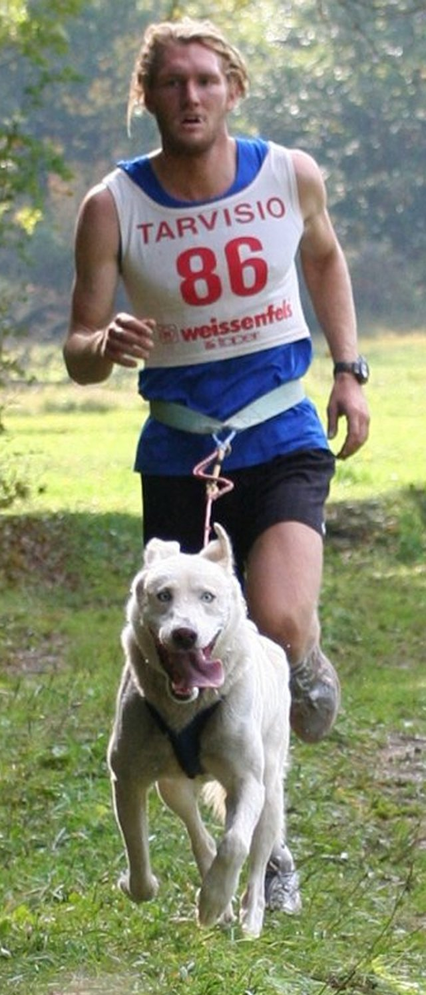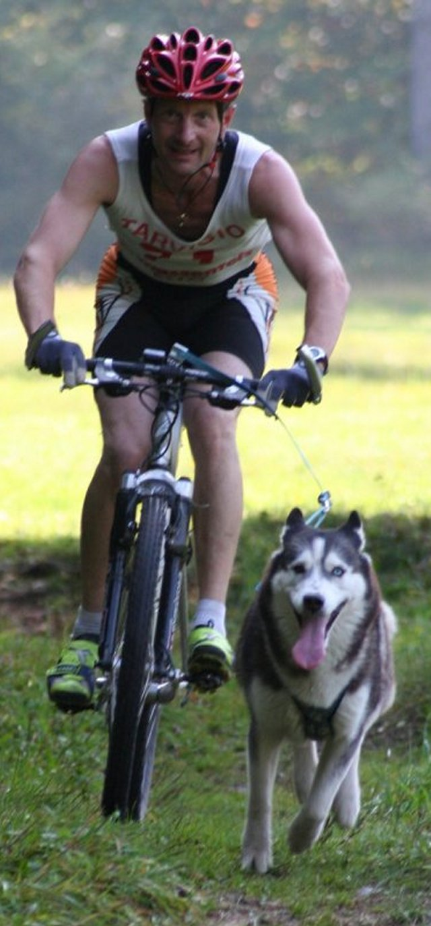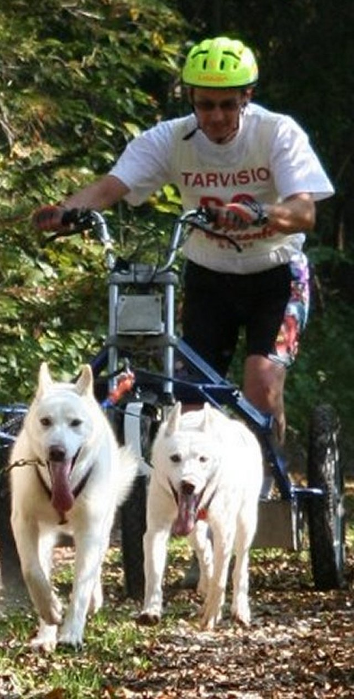

MANDATORY ENTRY within FRIDAY the 21st / 09 / 2007 at 7 p.m.

RACE INFO - ENTRIES : tel. 0039 / 348 / 26.85.867 or 348 / 37.45.119,

e mail mushing@libero.it

INFO HOTELS : Italia 0039 / 0428 / 2135 - Slovenia : 00386 – 41 – 53.20.51

