SCUOLA INTERNAZIONALE MUSHING – S.I.M. Fusine -Tarvisio
SOCIETA’ ARKHA in cooperation with
FEDERAZIONE ITALIANA MUSHER SLEDDOG SPORT – F.I.M.S.S.

Invite you to the 2° Edition of the
INTERNATIONAL MUSHER’ S MEETING - FIESTA
SATURADY the 3Oth of Sept. 2006 10 am to 10 pm
TARVISIO –“ Città di Tarvisio “ big Tent

and to the

8th “TRIPLE CROWN TROPHY“ 4 Km. Race
CANICROSS, BIKE – DOG, KART – DOG, SCOOTER
“ CHALLENGE ITALIA CUP “- FIMSS
PIANA DI FUSINE – TARVISIO ( UD )
(Race Area on the n. 54 National Road at the Italy – Slovenia Borderline )

SUNDAY the 1st of October 2006, 10am – 1 pm

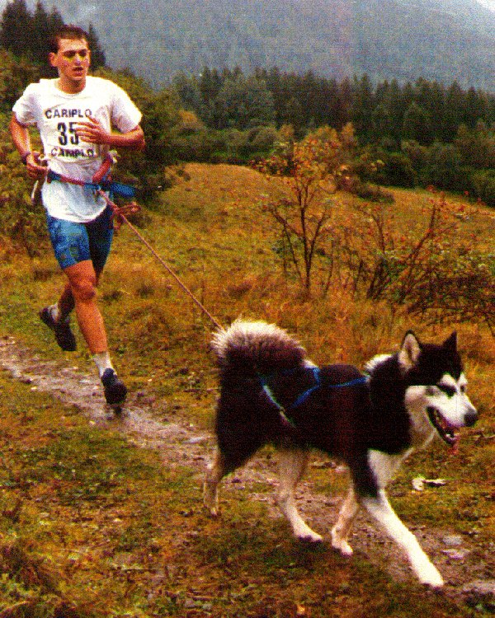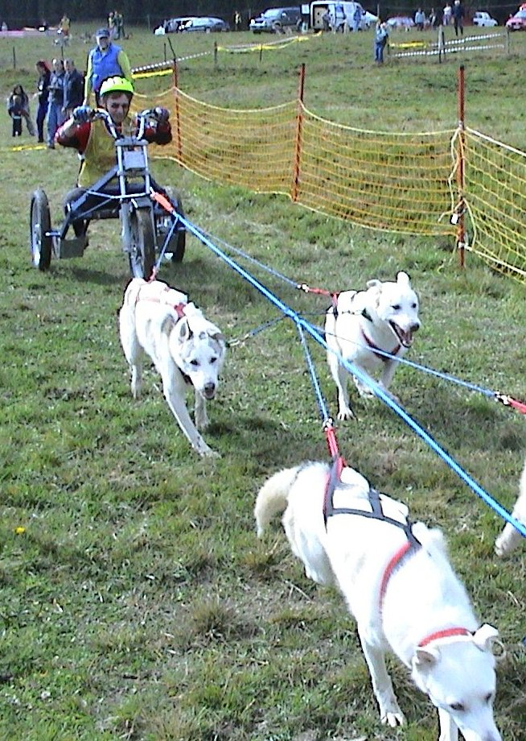

MANDATORY ENTRIES WITHIN FRIDAY THE 29 / September / 2006 at 7 pm.

RACE INFO, ENTRIES : tel. +39 - 348 / 26.85.867 or 0428 / 65.13.31 e mail ararad@ararad.net

INFO HOTELS AND TOURISM : A.I.A.T. +39 - 0428 / 2135 - Co.Pro.Tur. +39 - 0428 / 2392

